**Batch: D -1 Roll No.: 16010122096**

**Experiment No. 7**

|  |
| --- |
| **TITLE : To perform VLab on NLP** |

**AIM:** Vlab on NLP

**Expected OUTCOME of Experiment:**

CO5: Apply data analytics in the field of Health care.

**_____________________________________________________________________**

**Books/ Journals/ Websites referred:**

**_____________________________________________________________________**

**Pre Lab/ Prior Concepts:**

Students should have a basic understanding of word analysis.

**Procedure:**

**Vlab Name: Computer Science and Engineering -Natural Language Processing- Word Generation**

**Vlab Link:** [**https://nlp-iiith.vlabs.ac.in/exp/morphology/**](https://nlp-iiith.vlabs.ac.in/exp/morphology/)

Implementation details:

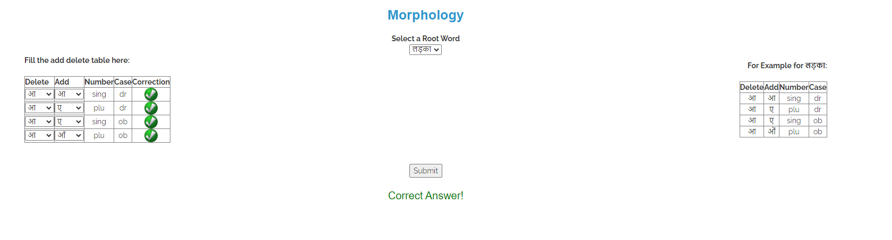

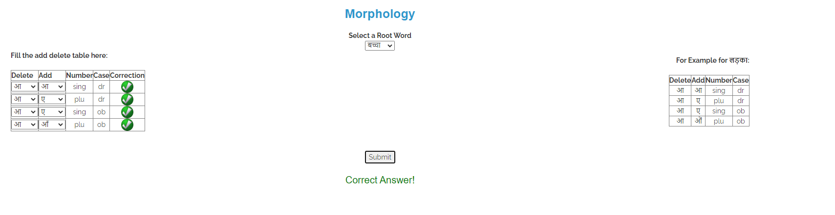

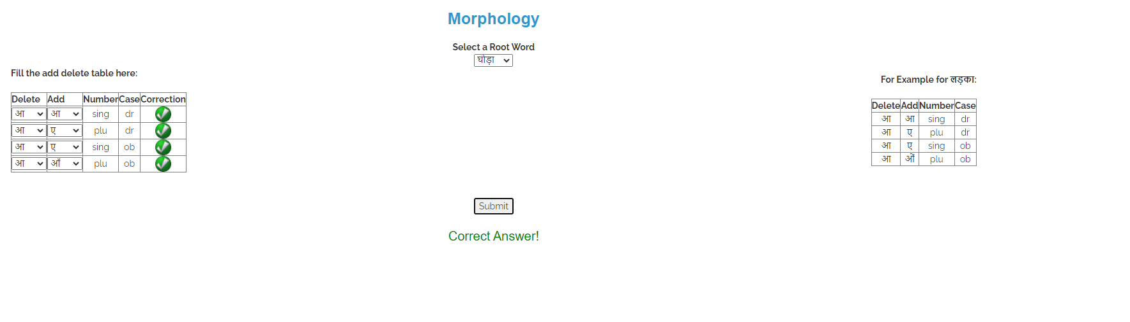 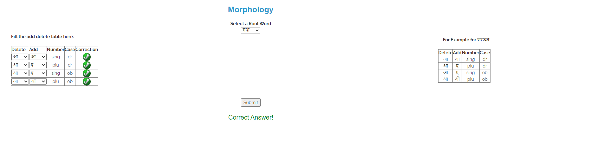

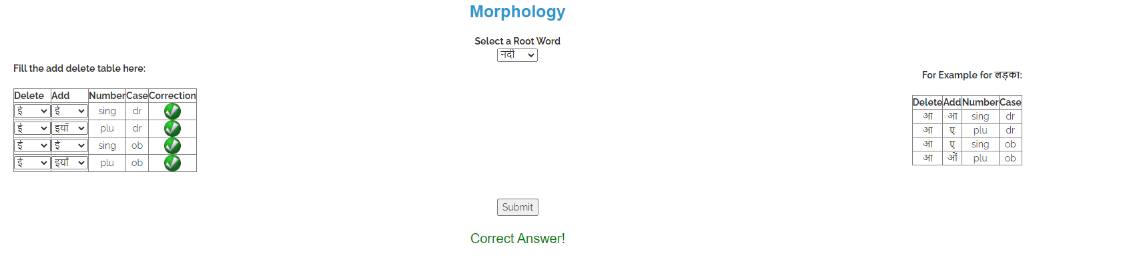



**Date: _____________ Signature of faculty in-charge**

**Post Lab Descriptive Questions:**

Q.1 Explain various applications of NLP.

Natural Language Processing (NLP) has a wide range of applications across various fields. Some of the key applications include:

1. **Sentiment Analysis:** Used to determine the sentiment (positive, negative, or neutral) expressed in text data, often applied in social media monitoring, product reviews, and market research.
2. **Chatbots and Virtual Assistants:** NLP powers chatbots and virtual assistants (like Siri, Alexa, and Google Assistant) to understand and respond to user queries in natural language.
3. **Machine Translation:** Tools like Google Translate use NLP to translate text between different languages, facilitating communication across language barriers.
4. **Text Summarization:** NLP techniques can automatically summarize long documents or articles, providing concise versions while preserving key information.
5. **Information Extraction:** NLP helps in extracting structured information from unstructured text, such as identifying entities (names, dates, locations) and relationships in documents.

Q.2 What is the significance of Natural Language Processing (NLP) in modern technology, and how does it impact various industries?

NLP plays a crucial role in modern technology and has significant impacts across various industries:

1. **Enhanced Human-Computer Interaction:** NLP enables more intuitive and natural interactions between users and computers, making technology accessible to a broader audience.
2. **Improved Customer Service:** By automating responses through chatbots and virtual assistants, businesses can provide 24/7 support, reduce response times, and enhance customer satisfaction.
3. **Data Analysis and Insights:** NLP allows organizations to analyze large volumes of textual data to extract insights, trends, and sentiments, aiding in decision-making and strategy formulation.
4. **Content Management:** In sectors like publishing and media, NLP helps in managing, categorizing, and summarizing vast amounts of content efficiently.
5. **Healthcare Applications:** NLP assists in extracting information from medical records and research papers, facilitating better patient care and improving clinical decision-making.